**Steps to Install JMeter**

**Step 1) Install Java**

Because JMeter is pure Java desktop application, it requires a fully compliant JVM 6 or higher. You can download and install the latest version of Java SE Development Kit.

[](http://cdn.guru99.com/images/JavaDownload.png)

[Java Platform (JDK)](http://www.oracle.com/technetwork/java/javase/downloads/index.html)

Click on JDK and download them

After installation is finished, you can use the following procedure to check whether Java JDK is installed successfully in your system

* In Window/Linux, go to **Terminal**
* Enter command **java -version**

If Java runtime environment is installed successfully, you will see the output as figure below

[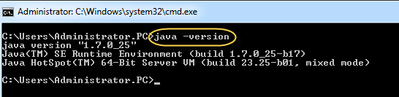](http://cdn.guru99.com/images/Administrator.png)

If nothing displays, please re-install Java SE runtime environment

**Step 2) Download Jmeter**

As of this writing, the latest version of JMeter is **Apache JMeter 3.2**.You can download it [here](http://jmeter.apache.org/download_jmeter.cgi)

Choose the Binaries file (either zip or tgz) to download as shown in figure below

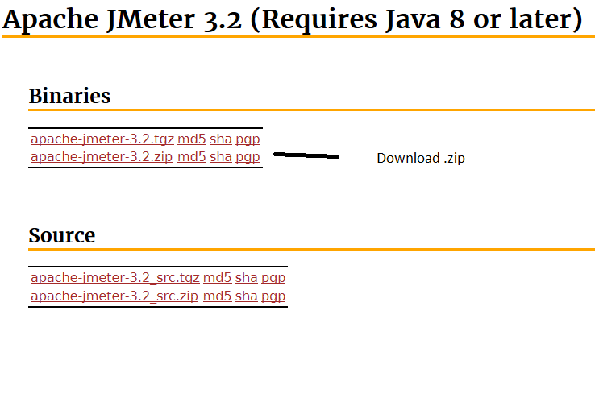

**Step 3) Installation**

Installation of JMeter is extremely easy and simple. You simply unzip the zip/tar file into the directory where you want JMeter to be installed. There is no tedious installation screen to deal with! Simple unzip and you are done!

Once the unzipping is done installation directory structure should look like as figure below

Note: This snapshot is for version 2.9, same steps for any latest version as well

[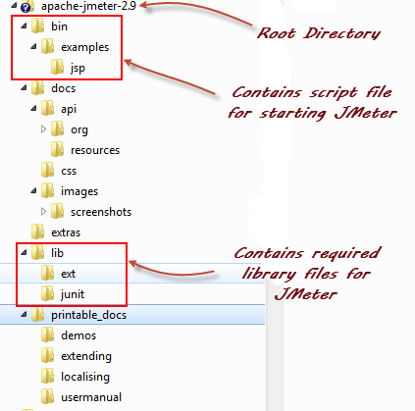](http://cdn.guru99.com/images/ApacheJmeter2_9.png)

Given below is the description of the JMeter directories and its importance JMeter directory contains many files and directory

* /**bin**: Contains JMeter script file for starting JMeter
* /**docs**: JMeter documentation files
* **/extras**: ant related extra files
* /**lib**/: Contains the required Java library for JMeter
* **/lib/ext**: contains the core jar files for JMeter and the protocols
* **/lib/junit**: library used for JMeter Junit
* /**printable_docs**:

**Step 4) Launch JMeter**

You can start JMeter in 3 modes

* GUI Mode
* Server Mode – will discuss in the class
* Command Line Mode – will discuss in the class

**Start JMeter in GUI Mode**

If you are using Window, just run the file **/bin/jmeter.bat** to start JMeter in GUI mode as shown below

[](http://cdn.guru99.com/images/startjmeter.gif)

Following figure annotates the various components in the JMeter GUI

[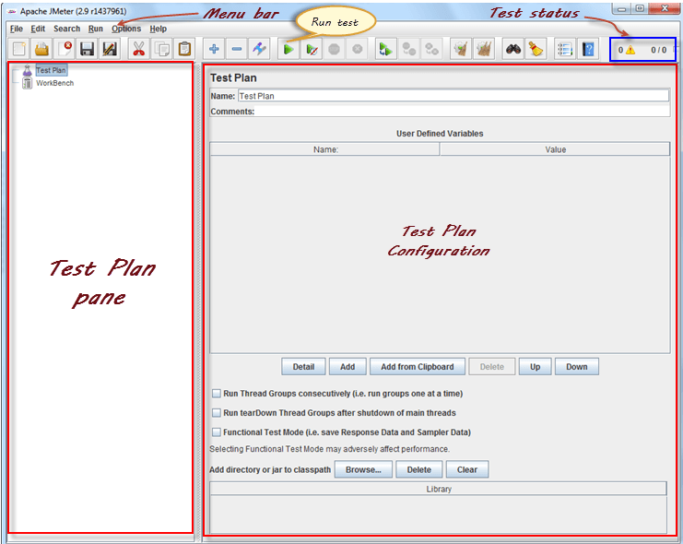](http://cdn.guru99.com/images/ApacheJmeterSnap.png)